ARP (Address Resolution Protocol)
A networking protocol which is used to map IP address with mac address.
When ping to another computer the source Doesn’t know the destination mac address, so 1st the ARP runs to find the mac address of destination computer. While ARP the source sets the destination mac address to broadcast FF:FF:FF:FF:FF:FF then the switch broadcasts it to all the pc’s except for the source itself. The device whose ip address matches then replies back to the source with their mac, then only there is connection and actual ping runs (ICMP).

OSI Layers
Memorization line(From CLaude):
ALL = Application PDU-> Data
People = Presentation PDU-> Data
Seem = Session PDU-> Data
To = Transport PDU-> Segment
Need = Network PDU-> Packet
Data = Data Link PDU-> Frame
Processing = Physical PDU-> Bits

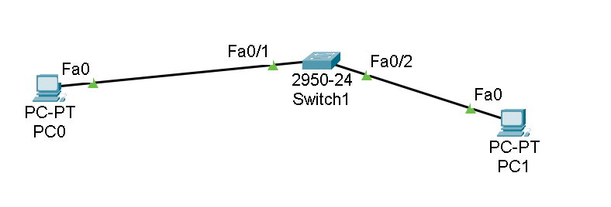
Evidences:

